

***Operating Lease Support System Phase-2 Project***

***for***

****

***Functional Specification***

***FC.AB.2.2 Approval SKD***

Revision 1.0

**PT. Berlian Sistem Informasi**

KTB Annex Bld. 4th Floor, Jl. Jend. A. Yani. Pulomas,

Tel. +62 21 4786 7575 (Hunting) Fax. +62 21 4714964 www.bsi.co.id

Document Control

|  |  |
| --- | --- |
| **Author** | Raymond |
| **File Name** |  |
| **Path** |  |
| **Number of Page** |  |

Revision History

|  |  |  |  |
| --- | --- | --- | --- |
| **Date** | **Revision** | **Description** | **Author** |
| 1/10/2015 | 0.0 | Initialization | Raymond |
| 24/11/2015 | 0.1 | * Adding Functional Specification for Check SKD * Adding Functional Specification for Approve SKD * Adding Functional Specification for Revise SKD * Adding Functional Specification for Reject SKD | Raymond |
| 23/12/2015 | 1.0 | 1st baseline | Raymond |

Distribution List

|  |  |  |
| --- | --- | --- |
| Name | Organization | Roles |
| Mr. Jin Nishimura | Dipo Star Finance, PT | DSF Project Director |
| Mr. Shinji Hosokawa | Dipo Star Finance, PT | DSF Project Advisor |
| Mr. Ahmad Fikri | Dipo Star Finance, PT | DSF Project Advisor |
| Mr. Abdul Somad | Dipo Star Finance, PT | DSF Project Manager |
| Mr. Delta Riangga | Dipo Star Finance, PT | DSF Key User |
| Mr. Mochamad Idris | Dipo Star Finance, PT | DSF Key User |
| Mrs. Herni Hembang | Dipo Star Finance, PT | DSF Key User |
| Mr. Junaidi Didy | Dipo Star Finance, PT | DSF Key User |
| Mr.Dedy Supriyadi | Dipo Star Finance, PT | DSF Key User |
| Mrs. Elke Hilviana | Dipo Star Finance, PT | DSF Key User |
| Mr. Mukhlis Ibrahim | Dipo Star Finance, PT | DSF IT Department Representative |
| Mr. Roby Wijaya | Dipo Star Finance, PT | DSF IT Department Representative |
| Mr. Daiki Kamada | Berlian Sistem Informasi, PT | BSI Project Director |
| Mr. Feri Irawan | Berlian Sistem Informasi, PT | BSI Project Advisor |
| Mr. Grand Zah Putra | Berlian Sistem Informasi, PT | BSI Project Manager |
| Mr. Raymond | Berlian Sistem Informasi, PT | BSI Business Analyst |

Document Approval

By signing this document I acknowledge I have read the document and give the Project Management Team approval to proceed.

|  |  |  |  |
| --- | --- | --- | --- |
| Role | Name | Signature | Date |
| DSF Project Director | Mr. Jin Nishimura |  |  |
| DSF Project Advisor | Mr. Ahmad Fikri |  |  |
| DSF Project Manager | Mr. Abdul Somad |  |  |
| DSF IT Department Representative | Mr. Mukhlis Ibrahim |  |  |
| BSI Project Director | Mr. Daiki Kamada |  |  |
| BSI Project Advisor | Mr. Feri Irawan |  |  |
| BSI Project Manager | Mr. Grand Zah Putra |  |  |
| BSI Business Analyst | Mr. Raymond |  |  |

Table of Contents

Document Control 2

Revision History 2

Distribution List 3

Document Approval 4

1. Introduction 6

1.1 Purpose 6

1.2 Scope 6

1.3 Definition, Acronyms, and Abbreviations 6

1.4 References 6

2. Configuration 7

3. Specification Detail: FC.AB.2.2 Approval SKD 7

3.1 Purpose 7

3.2 Screen of Configuration Access 7

3.3 Screen Functionality 7

3.4 Operation Flow 8

3.5 Screen Design 9

3.6 Component Screen Functionality 11

3.7 Operation Description 14

3.8 Data Structure 19

3.9 Screen Item List 24

3.10 Entity Relationship Diagram 25

1. Introduction
   1. Purpose

Functional Specification is a document to describe the detail of functions system which includes screen design, report, and logic formula. This document will be used for system development.

* 1. Scope

Functional Specification Document contains screen design, screen functionality, process flow, and data structure of FC.AB.2.1 Manage SKD for Phase-2

Here are the scope for FC.AB.2.1 Manage SKD

1. **AB.2.1.3 Approve SKD**

To approve a SKD (the function is the same with Check)

1. **AB.2.1.4 Reject SKD**

To reject a SKD and change it into Reject status

1. **AB.2.1.5 Revise SKD**

To set a SKD into revise status

Output from this functions is:

N/A

* 1. Definition, Acronyms, and Abbreviations

1. OPL = Operating Lease
2. DSF = Dipo Star Finance
3. BSI = Berlian Sistem Informasi
4. HOB = Head of Branch
5. HOD = Head of Department
6. RM = Regional Manager
7. SKD = Surat Keputusan Direksi/ Board of Director’s Decree
   1. References

This functional specification document refers to **“To Be Design” AB. Marketing Process**, module:

1. AB.2 SKD Process

* AB.2. SKD Creation of Operating Lease

1. Configuration

* N/A

1. Specification Detail: FC.AB.2.2 Approval SKD
   1. Purpose

The screens used in Approval SKD are used to Check, Approve, Revise, and Reject the SKD and generate an output as a print form of the SKD Form.

* 1. Screen of Configuration Access

Here are the access right for users:

|  |  |  |  |  |  |
| --- | --- | --- | --- | --- | --- |
| ***User*** | ***Check*** | ***Approve*** | ***Reject*** | **Revise** | **Authorization** |
| Marketing Officer | - | - | - | - | - |
| Head of Branch | v | v | v | v | v |
| Head of Department | v | v | v | v | v |
| Regional Manager | v | v | v | v | v |
| Advisor | v | v | v | v | v |
| Director | v | v | v | v | v |
| President Director | v | v | v | v | v |
| Shareholder’s Meeting | - | v | v | v | v |

Note:

1. Check: related to update SKD
2. Approve: related to update SKD
3. Reject: related to update SKD
4. Revise: related to update SKD
5. Authorization: related to approval process (check, approve, reject, revise) of SKD
   1. Screen Functionality
6. Check SKD
7. Approve SKD
8. Revise SKD
9. Reject SKD
   1. Operation Flow

Below is operation flow for Monitoring and print unit preparation process refer to **To Be Design Document Marketing Process**, **AB.2 Board of Director’s Decree/ Surat Keputusan Direksi (SKD)**:

|  |  |
| --- | --- |
| **PIC PC** | **Process** |
|  | Status  (Tb\_OPL\_Status)  F:\FINAL\SKD\SKD_View.png  Branch  (Tb\_OPL\_Branch)  Supplier Master data  (Supplier)    Quotation  (OPLQuotation)  SKD Detail  (Tb\_MKT\_SKD\_Dtl)  SKD  (Tb\_MKT\_SKD)  Note:  Source  Output & Input |

* 1. Screen Design
* *View SKD (for approval)*

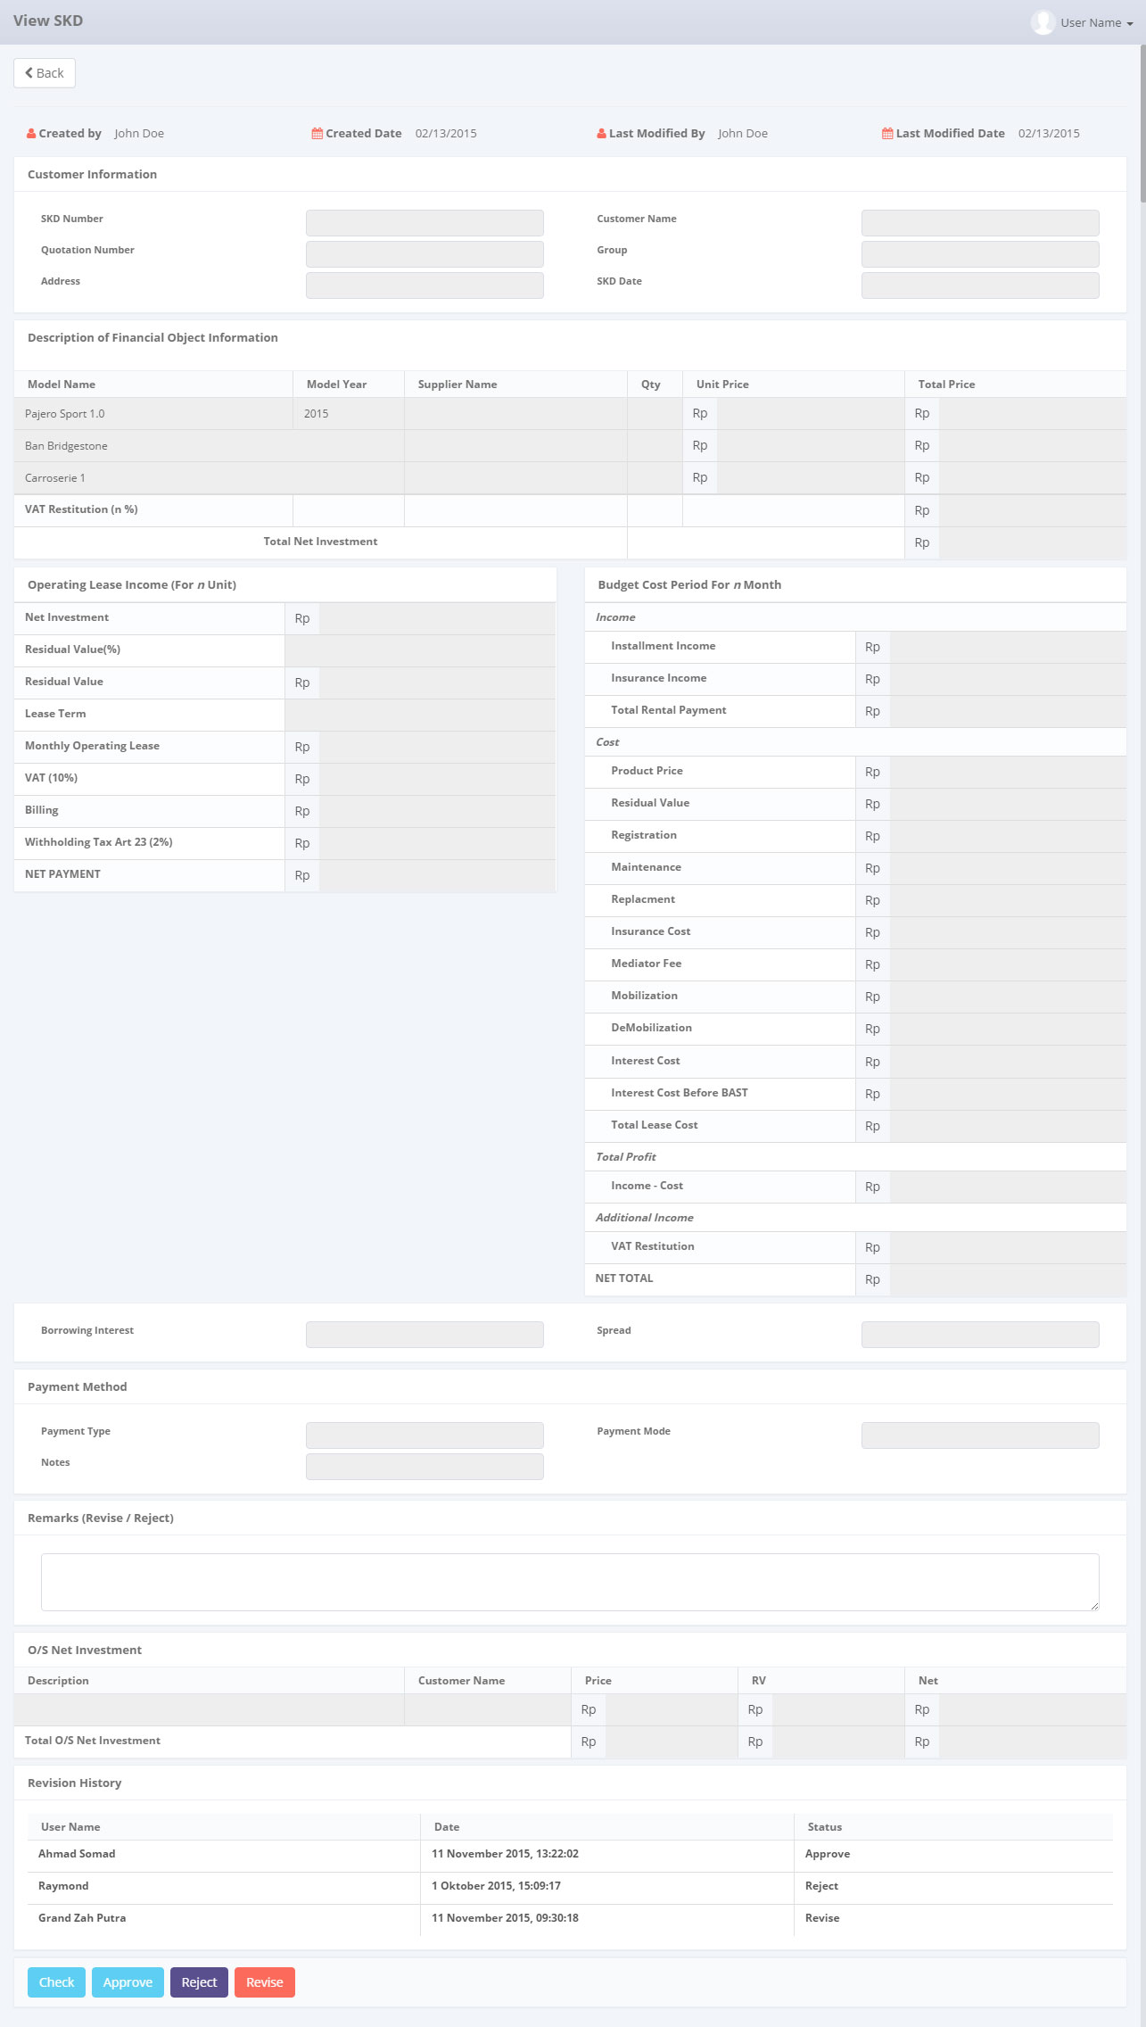

*Screen 1. View SKD*

* *Notification After Check*



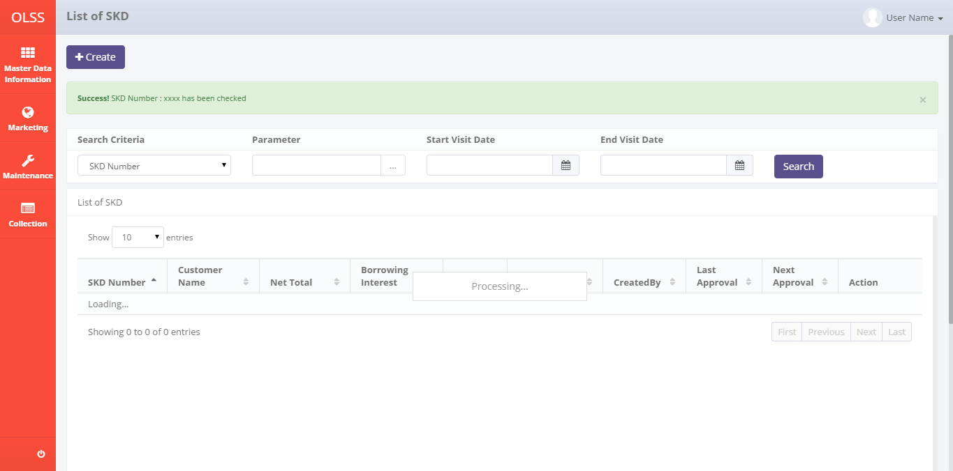

*Screen 2. List of SKD after check*

* *Notification after Approve*



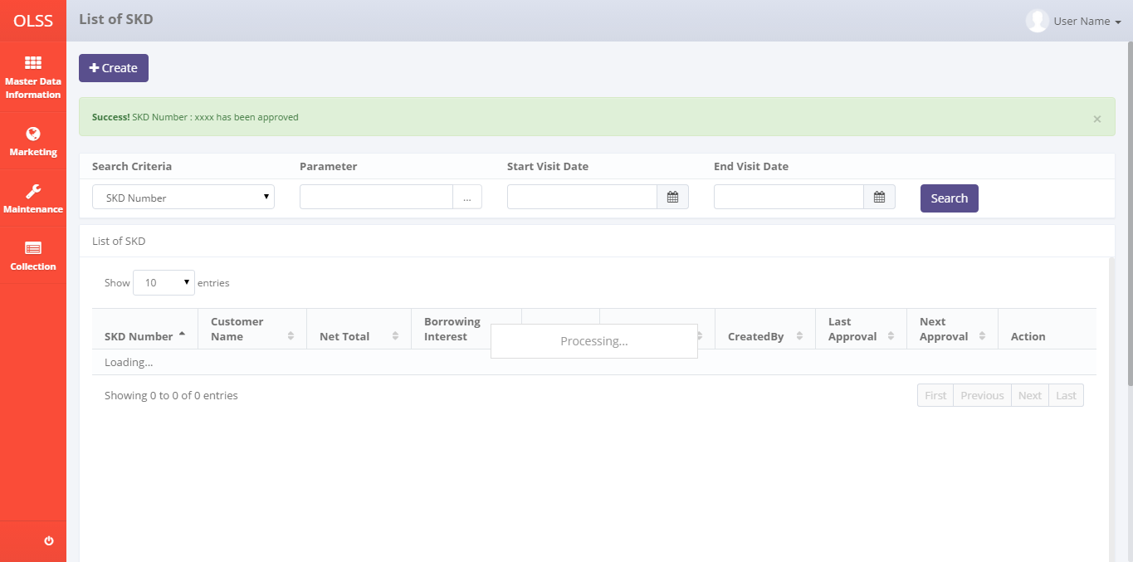

*Screen 3. List of SKD after approve*

* *Notification after Reject*



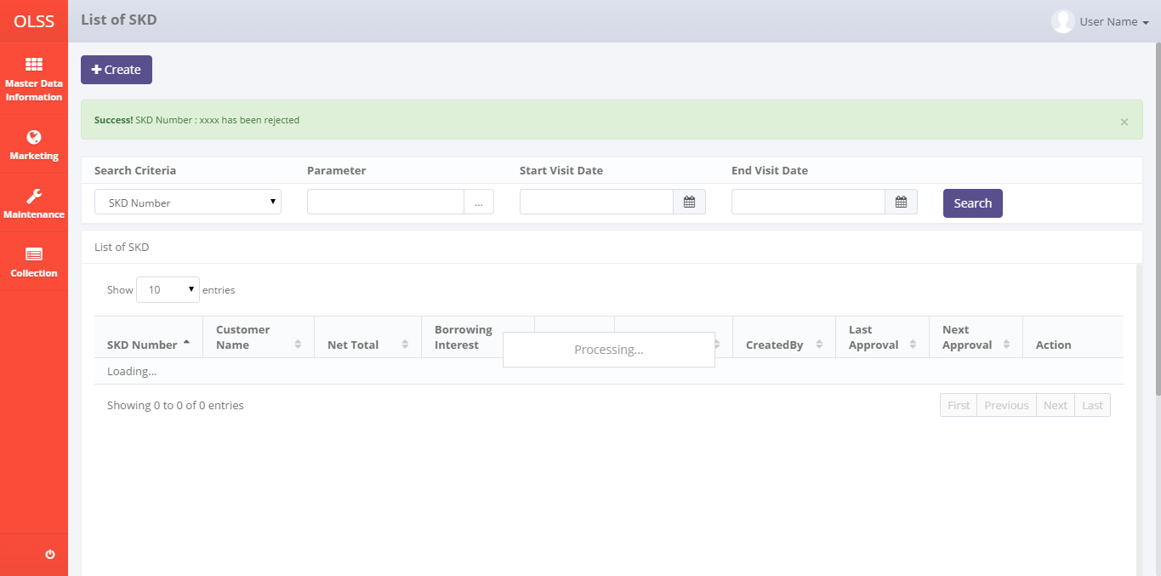

*Screen 4. List of SKD after reject*

* *Notification after Revise*



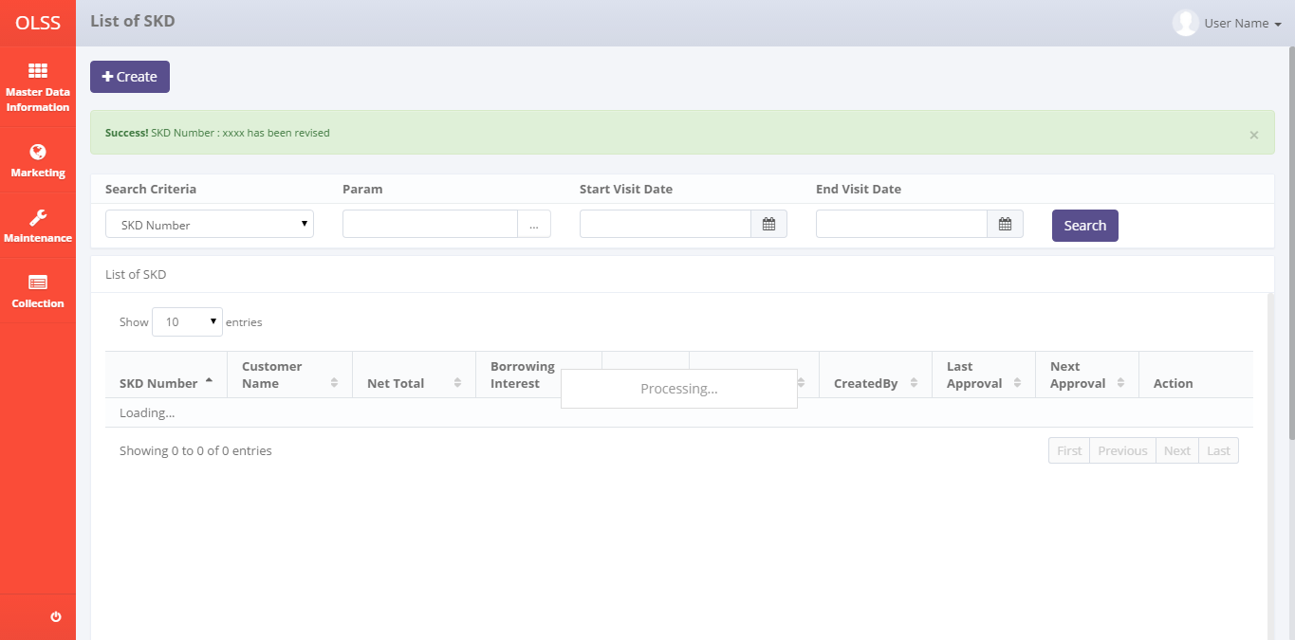

*Screen 5. List of SKD after revise*

* 1. Component Screen Functionality
  2. **View SKD (for approval)**

Here are the screen functions from each component in **Screen 1. View SKD (for approval)**:

|  |  |  |  |
| --- | --- | --- | --- |
| ***No*** | ***Component*** | ***Name*** | ***Function*** |
| **Header** | | | |
| 1 | Label | View SKD | View SKD title |
| 2 | Label | Created By | Displaying Created By |
| 3 | Label | Created Date | Displaying Created Date |
| 4 | Label | Last Modified By | Displaying Last Modified By |
| 5 | Label | Last Modified Date | Displaying Last Modified Date |
| **Customer Information** | | | |
| 6 | Text Box | SKD Number | Displaying SKD Number created |
| 7 | Searching Box | Quotation Number | To generate searching screen for Quotation No |
| 8 | Text Box | Address | To input Address value |
| 9 | Text Box | Customer Name | To input Customer Name value |
| 10 | Text Box | Group | To input Group value |
| 11 | Date Picker | SKD Date | To input SKD created date value |
| **Description of Financial Object Information** | | | |
| 12 | Text Box | Model Name | Displaying Model Name |
| 13 | Text Box | Model Year | Displaying Model Year |
| 14 | Searching Box | Supplier Name | To generate searching screen for Supplier Name |
| 15 | Text Box | Qty | Displaying Qty |
| 16 | Text Box | Unit Price | Displaying Unit Price |
| 17 | Text Box | Total Price | Displaying Total Price |
| 18 | Text Box | Delivery Fee | Displaying Delivery Fee |
| 19 | Text Box | Total Net Investment | Displaying Total Net Investment |
| **Operating Lease Income (For n Unit)** | | | |
| 20 | Text Box | Net Investment | Displaying Net Investment |
| 21 | Text Box | Residual Value(%) | Displaying Residual Value(%) |
| 22 | Text Box | Residual Value(Rp) | Displaying Residual Value(Rp) |
| 24 | Text Box | Lease Term | Displaying Lease Term |
| 25 | Text Box | Monthly Operating Lease | Displaying Monthly Operating Lease |
| 26 | Text Box | VAT (10%) | Displaying VAT (10%) |
| 27 | Text Box | Billing | Displaying Billing |
| 28 | Text Box | Witholding Tax Art 23 (10%) | Displaying Witholding Tax Art 23 (10%) |
| 29 | Text Box | NET PAYMENT | Displaying NET PAYMENT |
| **Budget Cost Period For n Month** | | | |
| 30 | Label | Income | Displaying Income field |
| 31 | Text Box | Total Rental Payment | Displaying Total Rental Payment |
| 32 | Label | Expense | Displaying Budget Cost Period For n Month field |
| 33 | Text Box | Interest | Displaying Interest |
| 34 | Text Box | Registration Value | Displaying Registration Value |
| 35 | Text Box | Insurance Premi | Displaying Insurance Premi |
| 36 | Text Box | Polis Insurance | Displaying Polis Insurance |
| 37 | Text Box | Mediator Fee | Displaying Mediator Fee |
| 38 | Text Box | Maintenance | Displaying Maintenance |
| 39 | Text Box | Accessories Expense | Displaying Accessories Expense |
| 40 | Text Box | Gain Value | Displaying Gain Value |
| 41 | Text Box | Total Expense | Displaying Total Expense |
| 42 | Label | Total Profit | Displaying Total Profit field |
| 43 | Text Box | (Total Income - Total Expense) | Displaying (Total Income - Total Expense) |
| **Revision History** | | | |
| 44 | Label | Revision History | Revision History sub-title |
| 45 | Label | User Name | Displaying User Name |
| 46 | Label | Date | Displaying Date |
| 47 | Label | Status | Displaying Status |
| **Footer** | | | |
| 48 | Text Box | Borrowing Interest | Displaying Borrowing Interest |
| 49 | Text Box | Spread | Displaying Spread |
| 50 | Label | Payment Method | Displaying Payment Method field |
| 51 | Text Box | Payment Type | Displaying Payment Type |
| 52 | Text Box | Payment Mode | Displaying Payment Mode |
| 53 | Text Box | Notes | Displaying Notes |
| 54 | Label | Revision Log | Displaying revision log |
| 55 | Text Area | Remarks (Reject/ Revise) | To input remarks of revision or rejection |
| 56 | Button | Check | To check a SKD |
| 57 | Button | Approve | To approve a SKD |
| 58 | Button | Reject | To reject a SKD |
| 59 | Button | Revise | To revise a SKD |

* 1. Operation Description

|  |  |  |
| --- | --- | --- |
| **No.** | **Operation Name** | **Description** |
| 1 | Initial view of View SKD (for approval) | The screen for View SKD:   1. Status component;  |  |  |  |  | | --- | --- | --- | --- | | Component | Name/Caption | Status | Remark | | Label | View SKD | Not Active |  | | Button | Back | Active |  | | Label | Created By | Not Active |  | | Label | Created Date | Not Active |  | | Label | Last Modified By | Not Active |  | | Label | Last modified Date | Not Active |  | | Label | Customer Information | Not Active |  | | Text Box | SKD Number | Not Active |  | | Searching Box | Quotation Number | Not Active |  | | Text Box | Address | Not Active |  | | Text Box | Customer Name | Not Active |  | | Text Box | Group | Not Active |  | | Date Picker | SKD Date | Not Active |  | | Label | Description of Financial Object Information | Not Active |  | | Text Box | Model Name | Not Active |  | | Text Box | Model Year | Not Active |  | | Searching Box | Supplier Name | Not Active |  | | Text Box | Qty | Not Active |  | | Text Box | Unit Price | Not Active |  | | Text Box | Total Price | Not Active |  | | Text Box | Delivery Fee | Not Active |  | | Text Box | Total Net Investment | Not Active |  | | Label | Operating Lease Income (For n Unit) | Not Active |  | | Text Box | Net Investment | Not Active |  | | Text Box | Residual Value(%) | Not Active |  | | Text Box | Residual Value(Rp) | Not Active |  | | Text Box | Lease Term | Not Active |  | | Text Box | Monthly Operating Lease | Not Active |  | | Text Box | VAT (10%) | Not Active |  | | Text Box | Billing | Not Active |  | | Text Box | Witholding Tax Art 23 (10%) | Not Active |  | | Text Box | NET PAYMENT | Not Active |  | | Label | Budget Cost Period For n Month | Not Active |  | | Label | Income | Not Active |  | | Text Box | Total Rental Payment | Not Active |  | | Label | Expense | Not Active |  | | Text Box | Interest | Not Active |  | | Text Box | Registration Value | Not Active |  | | Text Box | Insurance Premi | Not Active |  | | Text Box | Polis Insurance | Not Active |  | | Text Box | Mediator Fee | Not Active |  | | Text Box | Maintenance | Not Active |  | | Text Box | Accessories Expense | Not Active |  | | Text Box | Gain Value | Not Active |  | | Text Box | Total Expense | Not Active |  | | Label | Total Profit | Not Active |  | | Text Box | (Total Income - Total Expense) | Not Active |  | | Text Box | Borrowing Interest | Not Active |  | | Text Box | Spread | Not Active |  | | Label | Payment Method | Not Active |  | | Text Box | Payment Type | Not Active |  | | Text Box | Payment Mode | Not Active |  | | Text Box | Notes | Not Active |  | | Text Area | Remarks (Reject/Revise) | Active |  | | Label | Revision History | Not Active |  | | Label | User Name | Not Active |  | | Label | Date | Not Active |  | | Label | Status | Not Active |  | | Button | Check | Active |  | | Button | Approve | Active |  | | Button | Reject | Active |  | | Button | Revise | Active |  | |
| 2 | Check SKD | Input:   1. Click on the Check button   D:\Users\bsi00815\AppData\Local\Microsoft\Windows\Temporary Internet Files\Content.Word\SKD_View.png  Constraint:   1. Check button will only appear on Checker user screen (without Approve button). There are no Check button and Approve button appear on one same screen 2. The button will only enabled for the user whom the approval hierarchy is below the approval limit from the lowest of the hierarchy 3. A pop up will appear and ask for confirmation of choice   **“Are you sure you want to Check ?”**     1. Click on Yes   Process:   1. Update table Tb\_MKT\_SKD  * IdTb\_OPL\_Status = Current status ( get IdTb\_OPL\_Status from Tb\_OPL\_Status where StatusCode = “Check”) * TaskId= New Guid * LastModifiedBy = Sys.CurrentUser * LastModifiedDate = Sys.CurrentDate  1. Insert into Tb\_MKT\_SKD\_History  * ProcessID = New Guid * OriginalID = IdTb\_MKT\_SKD * CreatedDate = Sys.CurrentDate * CreatedBy = Sys.CurrentUser * Action = “Check”   Output:   1. The List of SKD will show the last approval and next approval PIC 2. The List of SKD will show “Check” on Status column 3. The next Authorized Person’s Check, Approve, Reject, and Revise buttons will be active 4. The button Check, Approve, Reject, and Revise will be disabled for the user who has done the Check   Altenative:   1. From step 2, click on Back button to go back to previous menu (List of SKD) 2. If the checker is not available to Check in within 3 days, the Check authority will move to next Authorized Person above. There will only need an Approve by the Authorized Person who is in the amount limit if all the checker is not available |
| 3 | Approve SKD | Input:   1. Click on the Approve button     Constraint:   1. Approve button will only appear on approver user screen (without Check button). There are no Check button and Approve button appear on one same screen 2. The button will only enabled for the user whom the amount limit has been reached and after all the Checker has checked the document 3. A pop up will appear and ask for confirmation of choice   **“Are you sure you want to Approve ?”**     1. Click on Yes   Process:   1. Update table Tb\_MKT\_SKD  * IdTb\_OPL\_Status = Current status ( get IdTb\_OPL\_Status from Tb\_OPL\_Status where StatusCode = “Approve”) * TaskId= New Guid * LastModifiedBy = Sys.CurrentUser * LastModifiedDate = Sys.CurrentDate  1. Create Tb\_MKT\_SKD\_History  * ProcessID = New Guid * OriginalID = IdTb\_MKT\_SKD * CreatedDate = Sys.CurrentDate * CreatedBy = Sys.CurrentUser * Action = “Approve”   Output:   1. The List of SKD will show the last approval and next approval PIC 2. The List of SKD will show Approve on Status column 3. The button Check, Approve, Reject, and Revise will be disabled for the user who has done the Approve   Altenative:   1. From step 2, click on Back button to go back to previous menu (List of SKD) 2. If the approver is not available to Approve in within 3 days, the Approve authority will move to next Authorized Person above. The move will be limited only until Director Role and won’t move up anymore |
| 4 | Revise SKD | Input:   1. Input the Remarks (Reject/ Revise)   Constraint:   1. Every field inputted cannot exceed maximum length defined in database system 2. Revise button will only appear on approver user screen 3. The button will be enabled for the user from the lowest hierarchy and the higher authority will be enabled also if the lower hierarchy has done Check or Revise 4. Click on the Revise button      1. Input the Remarks (Reject/ Revise)   Constraint:   1. Every field inputted cannot exceed maximum length defined in database system 2. Revise button will only appear on approver user screen 3. The button will be enabled for the user from the lowest hierarchy and the higher authority will be enabled also if the lower hierarchy has done Check or Revise 4. A pop up will appear and ask for confirmation of choice   **“Are you sure you want to Revise ?”**     1. Click on Yes   Process:   1. Update table Tb\_MKT\_SKD  * IdTb\_OPL\_Status = Current status ( get IdTb\_OPL\_Status from Tb\_OPL\_Status where StatusCode = “Revise”) * TaskId= New Guid * Notes = Remarks (Revise / Reject) * LastModifiedBy = current user * LastModifiedDate = current date (DateTime.Now)  1. Create Tb\_MKT\_SKD\_History  * ProcessID = New Guid * OriginalID = IdTb\_MKT\_SKD * CreatedDate = Sys.CurrentDate * CreatedBy = Sys.CurrentUser * Action = “Revise”   Output:   1. The List of SKD will show the next approval PIC (back to the lowest) 2. The List of SKD will show “Revise” on Status column 3. The button Check, Approve, Reject, and Revise will be disabled until the document status changed into Submit   Altenative:   1. From step 1, click on Back button to go back to previous menu (List of SKD) |
| 5 | Reject SKD | Input:   1. Click on the reject button      1. Input the Remarks (Reject/ Revise)   Constraint:   1. Every field inputted cannot exceed maximum length defined in database system 2. A pop up will appear and ask for confirmation of choice   **“Are you sure you want to Reject ?”**     1. Click on Yes   Process:   1. Update table Tb\_MKT\_SKD  * IdTb\_OPL\_Status = Current status ( get IdTb\_OPL\_Status from Tb\_OPL\_Status where StatusCode = “Reject”) * TaskId= New Guid * Notes = Remarks (Revise / Reject) * LastModifiedBy = Sys.CurrentUser * LastModifiedDate = Sys.CurrentDate  1. Create Tb\_MKT\_SKD\_History  * ProcessID = New Guid * OriginalID = IdTb\_MKT\_SKD * CreatedDate = Sys.CurrentDate * CreatedBy = Sys.CurrentUser * Action = “Reject”  1. All the Approval button like Check, Approve, Revise, and Reject will be inactive on all user for the related SKD   Output:   1. The List of SKD will show the last approval PIC 2. The List of SKD will show “Reject” on Status column 3. The button Check, Approve, Reject, and Revise will be disabled for the related SKD   Altenative:   1. From step 1, click on Back button to go back to previous menu (List of SKD) |
| 6 | System error message | Process:   1. Any errors outside of application validation or that which cannot be handled by application such as errors when communicating with database, bugs, overloop, etc will generate an error message “System error. Please contact your administrator”   Output:   1. A page with system error message will appear. |

* 1. Data Structure

1. **View SKD (for approval)**

Here are the data structure in **Screen 1. View SKD (for approval)**:

|  |  |  |  |  |  |  |
| --- | --- | --- | --- | --- | --- | --- |
| *Field Name* | *Data Type* | *Length* | *Source* | *Remarks* | *Nullable* | *Mandatory* |
| SKD Number | *Varchar* | *50* | Tb\_MKT\_SKD.SKDNo |  | *No* | *Yes* |
| Quotation Number | *Varchar* | *50* | OPLQuotation.OPLQuotationNumber | *Where*  *Tb\_MKT\_SKD.IdOPLQuotation = OPLQuotation. IdOPLQuotation* | *No* | *Yes* |
| Address | *nvarchar* | *MAX* | Customer.Address | *Where*  *Tb\_MKT\_SKD.IdCustomer = Customer. IdCustomer* | *No* | *Yes* |
| Customer Name | *varchar* | *200* | Customer.CustomerName | *Where*  *Tb\_MKT\_SKD.IdCustomer = Customer. IdCustomer* | *No* | *Yes* |
| Group | *Varchar* | *200* | Customer. Group | *Where*  *Tb\_MKT\_SKD.IdCustomer = Customer. IdCustomer* | *No* | *Yes* |
| SKD Date | *Date* | *N/A* | Tb\_MKT\_SKD.SKDDate |  | *No* | *Yes* |
| Model Name | *Varchar* | *100* | Product.ModelName | *Where*  *Tb\_MKT\_SKD.IdProduct = Product. IdProduct* | *No* | *Yes* |
| Model Year | *Date* | *N/A* | Product.ModelYear | *Where*  *Tb\_MKT\_SKD.IdProduct = Product. IdProduct* | *No* | *Yes* |
| Supplier Name | *Varchar* | *100* | Supplier.SupplierName | *Where*  *Tb\_MKT\_SKD.IdSupplier = Supplier. IdSupplier* | *No* | *Yes* |
| Qty | *Int* | *N/A* | OPLCalculation.TotalUnitQuantityLease | *Where*  *Tb\_MKT\_SKD.IdOPLQuotation = OPLQuotation. IdOPLQuotation*  *And*  *OPLCalculation.IdOPLCalculation = OPLQuotation. IdOPLCalculation* | *No* | *Yes* |
| Unit Price | *Decimal* | *18,3* | OPLBasicCondition.ProductPrice | *Where*  *Tb\_MKT\_SKD.IdOPLQuotation = OPLQuotation.IdOPLQuotation*  *And*  *OPLBasicCondition.IdOPLCalculation = OPLQuotation.IdOPLCalculation* | *No* | *Yes* |
| Operating Lease Income (For n Unit) | *Int* | *N/A* | OPLCalculation.TotalUnitQuantityLease | *Where*  *Tb\_MKT\_SKD.IdOPLQuotation = OPLQuotation. IdOPLQuotation*  *And*  *OPLCalculation.IdOPLCalculation = OPLQuotation. IdOPLCalculation* | *No* | *Yes* |
| VAT Restitution (n %) | *Decimal* | *18,3* | OPLCalculation.VATRestitution | *Where*  *Tb\_MKT\_SKD.IdOPLQuotation = OPLQuotation. IdOPLQuotation*  *And*  *OPLCalculation.IdOPLCalculation = OPLQuotation. IdOPLCalculation* | *No* | *Yes* |
| Net Investment | *Decimal* | *18,3* | Tb\_MKT\_SKD.NetInvestment |  | *No* | *Yes* |
| Residual Value(% x Unit Price) | *Decimal* | *18,3* | OPLBasicCondition.ResidualValuePercent | *Where*  *Tb\_MKT\_SKD.IdOPLQuotation = OPLQuotation.IdOPLQuotation*  *And*  *OPLBasicCondition.IdOPLCalculation = OPLQuotation.IdOPLCalculation* | *No* | *Yes* |
| Residual Value | *Decimal* | *18,3* | OPLBasicCondition.ResidualValueAmount | *Where*  *Tb\_MKT\_SKD.IdOPLQuotation = OPLQuotation.IdOPLQuotation*  *And*  *OPLBasicCondition.IdOPLCalculation = OPLQuotation.IdOPLCalculation* | *No* | *Yes* |
| Lease Term | *Int* | *N/A* | OPLCalculation.LeasePeriodPlan | *Where*  *Tb\_MKT\_SKD.IdOPLQuotation = OPLQuotation. IdOPLQuotation*  *And*  *OPLCalculation.IdOPLCalculation = OPLQuotation. IdOPLCalculation* | *No* | *Yes* |
| Monthly Operating Lease | *Decimal* | *18,3* | OPLCalculation.MonthlyInstallmentAmount | *Where*  *Tb\_MKT\_SKD.IdOPLQuotation = OPLQuotation. IdOPLQuotation*  *And*  *OPLCalculation.IdOPLCalculation = OPLQuotation. IdOPLCalculation* | *No* | *Yes* |
| Budget Cost Period For n Month | *Int* | *N/A* | OPLCalculation.LeasePeriodPlan | *Where*  *Tb\_MKT\_SKD.IdOPLQuotation = OPLQuotation. IdOPLQuotation*  *And*  *OPLCalculation.IdOPLCalculation = OPLQuotation. IdOPLCalculation* | *No* | *Yes* |
| Insurrance Income | *Decimal* | *18,3* | OPLCalculation.InsurranceCommisionAmount | *Where*  *Tb\_MKT\_SKD.IdOPLQuotation = OPLQuotation. IdOPLQuotation*  *And*  *OPLCalculation.IdOPLCalculation = OPLQuotation. IdOPLCalculation* | *No* | *Yes* |
| Product Price | *Decimal* | *18,3* | OPLBasicCondition.ProductPrice | *Where*  *Tb\_MKT\_SKD.IdOPLQuotation = OPLQuotation.IdOPLQuotation*  *And*  *OPLBasicCondition.IdOPLCalculation = OPLQuotation.IdOPLCalculation* | *No* | *Yes* |
| Residual Value | *Decimal* | *18,3* | OPLBasicCondition.ResidualValueAmount | *Where*  *Tb\_MKT\_SKD.IdOPLQuotation = OPLQuotation.IdOPLQuotation*  *And*  *OPLBasicCondition.IdOPLCalculation = OPLQuotation.IdOPLCalculation* | *No* | *Yes* |
| Registration | *Decimal* | *18,3* | OPLFinanceCondition.RegistrationValueAmount | *Where*  *Tb\_MKT\_SKD.IdOPLQuotation = OPLQuotation.IdOPLQuotation*  *And*  *OPLFinanceCondition.IdOPLCalculation = OPLQuotation.IdOPLCalculation* | *No* | *Yes* |
| Maintenance | *Decimal* | *18,3* | OPLMaintenanceCondition.TotalMaintenanceAmount | *Where*  *Tb\_MKT\_SKD.IdOPLQuotation = OPLQuotation.IdOPLQuotation*  *And*  *OPLMaintenanceCondition.IdOPLCalculation = OPLQuotation.IdOPLCalculation* | *No* | *Yes* |
| Replacement | *Decimal* | *18,3* | Tb\_MKT\_SKD.Replacement |  | *No* | *Yes* |
| Insurance Cost | *Varchar* | *500* | OPLInsuranceCondition.InsuranceCost | *Where*  *Tb\_MKT\_SKD.IdOPLQuotation = OPLQuotation.IdOPLQuotation*  *And*  *OPLInsuranceCondition.IdOPLCalculation = OPLQuotation.IdOPLCalculation* | *No* | *Yes* |
| Mediator Fee | *Decimal* | *18,3* | OPLInsuranceCondition.MediatorFeeAmount | *Where*  *Tb\_MKT\_SKD.IdOPLQuotation = OPLQuotation.IdOPLQuotation*  *And*  *OPLInsuranceCondition.IdOPLCalculation = OPLQuotation.IdOPLCalculation* | *No* | *Yes* |
| Mobilization | *Decimal* | *18,3* | OPLFinanceCondition.MobilizationFeeAmount | *Where*  *Tb\_MKT\_SKD.IdOPLQuotation = OPLQuotation.IdOPLQuotation*  *And*  *OPLFinanceCondition.IdOPLCalculation = OPLQuotation.IdOPLCalculation* | *No* | *Yes* |
| DeMobilization | *Decimal* | *18,3* | OPLFinanceCondition.DeMobilizationFeeAmount | *Where*  *Tb\_MKT\_SKD.IdOPLQuotation = OPLQuotation.IdOPLQuotation*  *And*  *OPLFinanceCondition.IdOPLCalculation = OPLQuotation.IdOPLCalculation* | *No* | *Yes* |
| Interest Cost | *Decimal* | *18,3* | OPLCalculation.InterestExpense | *Where*  *Tb\_MKT\_SKD.IdOPLQuotation = OPLQuotation. IdOPLQuotation*  *And*  *OPLCalculation.IdOPLCalculation = OPLQuotation. IdOPLCalculation* | *No* | *Yes* |
| Interest Cost before BAST | *Decimal* | *18,3* | OPLCalculation.InterestExpenseBAST | *Where*  *Tb\_MKT\_SKD.IdOPLQuotation = OPLQuotation. IdOPLQuotation*  *And*  *OPLCalculation.IdOPLCalculation = OPLQuotation. IdOPLCalculation* | *No* | *Yes* |
| Borrowing Interest | *Decimal* | *18,3* | OPLFinanceCondition.BorrowingEffectivePercent | *Where*  *Tb\_MKT\_SKD.IdOPLQuotation = OPLQuotation.IdOPLQuotation*  *And*  *OPLFinanceCondition.IdOPLCalculation = OPLQuotation.IdOPLCalculation* | *No* | *Yes* |
| Spread | *Decimal* | *18,3* | OPLFinanceCondition.SpreadEffectivePercent | *Where*  *Tb\_MKT\_SKD.IdOPLQuotation = OPLQuotation.IdOPLQuotation*  *And*  *OPLFinanceCondition.IdOPLCalculation = OPLQuotation.IdOPLCalculation* | *No* | *Yes* |
| Payment Type | *Varchar* | *100* | OPLFinanceCondition.PaymentType | *Where*  *Tb\_MKT\_SKD.IdOPLQuotation = OPLQuotation.IdOPLQuotation*  *And*  *OPLFinanceCondition.IdOPLCalculation = OPLQuotation.IdOPLCalculation* | *No* | *Yes* |
| Payment Mode | *Varchar* | *100* | Tb\_MKT\_SKD.PaymentMode |  | *No* | *Yes* |
| Notes | *Varchar* | *500* | Tb\_MKT\_SKD.Notes |  | *Yes* | *No* |
| RemarksSys | *Varchar* | *100* | Tb\_MKT\_SKD.RemarksSys |  | *Yes* | *No* |
| Created By | *Varchar* | *20* | Tb\_MKT\_SKD.CreatedBy |  | *No* | *Yes* |
| Created Date | *Datetime* | *N/A* | Tb\_MKT\_SKD.CreatedDate | *Format “YYYY-MM-DD hh:mm:ss.[nnn]”* | *No* | *Yes* |
| Last Modified By | *Varchar* | *20* | Tb\_MKT\_SKD.LastModifiedBy |  | *Yes* | *No* |
| Last Modified Date | *Datetime* | *N/A* | Tb\_MKT\_SKD.LastModifiedDate | *Format “YYYY-MM-DD hh:mm:ss.[nnn]”* | *Yes* | *No* |

* 1. Screen Item List

N/A

* 1. Entity Relationship Diagram

**